BIODATA
Name and Address:  Savita Sudhir Venegurkar  C-4, Morya Gosavi Raj Park, Phase-II,  Keshav nagar, Chinchwad,  Pune-411033 | 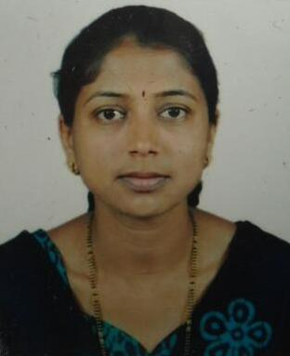
Designation: Assistant Professor
Educational Qualification: M.Sc. (Statistics)
Teaching Experience: 19 years, 8 months
- Teaching Experience in various colleges run by Pune District Education Association. Presently working as a Assistant Professor in Statistics in P.D.E.A’s Prof.Ramkrishna More A.C.S.College, Akurdi, Pune.
(Permanent Approval No. CCO/1665 Dated 24/05/1999 University of Pune)
Classes Taught: B. Sc.(Computer Science), B.Sc.(Statistics), M.Phil(Commerce)
Faculty development programmes (Orientation/ Refresher/ Short term courses):
Name of the course | Name of the Institute | Duration of Course | Date | Subject
Refresher | University of Pune | 21 days | 02/12/2002 to  21/12/2002 | I.T.  (Statistics)
Orientation | Academic Staff College, University of Pune | 28 days | 22/03/2004 to  18/04/2004 | -
Refresher | Academic Staff College, University of Mumbai | 21 days | 18/02/2009 to  10/03/2009 | I.T.  (Statistics)
Refresher | Academic Staff College, University of Pune | 21 days | 07/12/2009 to  27/12/2009 | Environmental Science

Research Area: Survival Analysis, Statistical Process Control
Research Projects: NIL

Research Articles published In Journals:
Sr.No. | Authors | Title of Paper | Name of Journal/Conference | ISSN/ISBN
1 | Savita Venegurkar | Data Mining and Statistics: Distinguishable Disciplines | EXCEL International Journal of Multidisciplinary Management Studies (EIJMMS),Vol.4 (5), MAY (2014), pp. 62-67 | ISSN 2249- 8834

Paper presented in International Conference: NIL
Paper presented in National/ State/ University level Conference: NIL
Awards/Honours: NIL
Books Published:
Co-author of textbook “Business Statistics”( B.B.A/B.B.M.-(I.B) Sem-II-205)
Publisher :Success Publications,Pune.
ISBN No. : 978-93-24457-06-3
Innovations in Curriculum design and transactions:
NIL
Resource Person: NIL
Seminars/Workshops/ Training courses attended:
Name of the Seminar/Workshop | Name of  Sponsoring Agency | Date | Duration
Seminar on Reliability Theory  and Its Applications. | Dept.of Statistics,  University of Pune | 21/06/2001 to 23/06/2001 | 3 days
Conference of I.S.P.S. & National seminar on Advances in Statistics | Dept.of Statistics,  University of Pune | 11/08/2002 to  14/08/2002 | 4 days
Workshop in MS-Excel and C  programming | Modern College,  Shivajinagar, Pune. | 08/12/2002 | 1 day
National Seminar on  “Recent Trends in Statistics” | Modern College,  Shivajinagar, Pune. | 08/12/2007 to 10/12/2007 | 3 days
International seminar on Sustainable Development | Dept.of Botany, University of Pune. | 08/12/2009 | 1 day
International workshop on Reliability Theory & Survival Analysis | Dept. of Statistics,  SPPU, Pune | 03/11/2016 to 05/11/2016 | 3 days
National Conference on Recent Advancements in Statistics & Their Applications to Society | Dept. of Statistics,  SPPU, Pune | 23/03/2017 to 25/03/2017 | 3 days

Participation in community/ Social Services: participation in tree plantation at Ghorawadeshwar along with Mathematics department of college.
Memberships on various bodies: NIL
Computer Skills: MS Office, C programming, R programming, MATLAB

